**A Mask Detection Method for Shoppers Under the Threat of COVID-19 Coronavirus**

**ABSTRACT:**

Object detection, which aims to automatically mark the coordinates of objects of interest in pictures or videos, is an extension of image classification. In recent years, it has been widely used in intelligent traffic management, intelligent monitoring systems, military object detection, and surgical instrument positioning in medical navigation surgery, etc. COVID-19, a novel coronavirus outbreak at the end of 2019, poses a serious threat to public health. Many countries require everyone to wear a mask in public to prevent the spread of coronavirus. To effectively prevent the spread of the coronavirus, we present an object detection method based on single-shot detector (SSD), which focuses on accurate and real-time face masks detection in the supermarket. We make contributions in the following three aspects: 1) presenting a lightweight backbone network for feature extraction, which based on SSD and spatial separable convolution, aiming to improve the detection speed and meet the requirements of real-time detection; 2) proposing a Feature Enhancement Module (FEM) to strengthen the deep features learned from CNN models, aiming to enhance the feature representation of the small objects; 3) constructing COVID-19-Mask, a large-scale dataset to detect whether shoppers are wearing masks, by collecting images in two supermarkets. The experiment results illustrate the high detection precision and real-time performance of the proposed algorithm.

**EXISTING SYSTEM:**

Supermarket belongs to the personnel intensive place, be infected possibility is very high. Although there are inspectors at the door of the supermarket to check the masks and temperature of shoppers. However, in some supermarkets, there are still some people who do not wear masks, which poses a great threat to public safety. This, in other words, raises the possibility of one infected person passing the virus to another.

**DISADVANTAGES OF EXISTING SYSTEM:**

* Needs manual checking
* Possibility of unidentified.

**PROPOSED SYSTEM:**

In this paper, we focus on real-time face masks detection, created a new dataset called COVID-19- Mask, which aims to automatically detect whether shoppers are wearing masks. Besides, we improved the SSD algorithm and designed a lightweight facemasks detection algorithm based on spatial separable convolution and Feature Enhancement Module (FEM).

The task includes two modules, the training module and the detection module. In the training section, the COVID-19- Mask dataset was used to train the model to obtain a mask detector. In the detection stage, images are obtained in realtime from the surveillance video, and then use the trained detector to determine whether the shoppers in the pictures are wearing masks. A warning will be issued if a shopper is detected not wearing a mask.

**ADVANTAGES OF PROPOSED SYSTEM:**

* Experimental results show that the proposed method does help the real-time detection of face masks.
* No need for manual checking
* Gives automatic alarm/beep when the person does not wear a mask.

**SYSTEM ARCHITECTURE:**

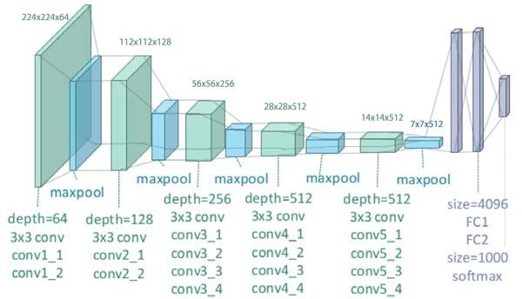

**SYSTEM REQUIREMENTS:**

**HARDWARE REQUIREMENTS:**

* System : Pentium i3 Processor.
* Hard Disk : 500 GB.
* Monitor : 15’’ LED
* Input Devices : Keyboard, Mouse
* Ram : 2 GB

**SOFTWARE REQUIREMENTS:**

* Operating system : Windows 10.
* Coding Language : Python

**REFERENCE:**

Wenxuan Han, Zitong Huang, Alifu.kuerban, Meng Yan, Haitang Fu, “A Mask Detection Method for Shoppers Under the Threat of COVID-19 Coronavirus”, IEEE CONFERENCE, 2020.